<http://www.fhdq.net/>

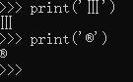

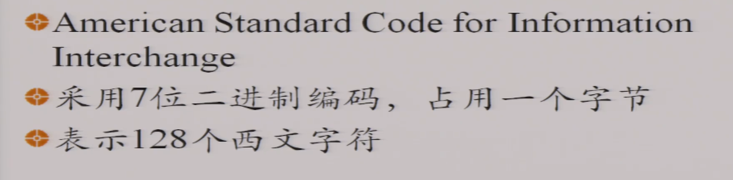

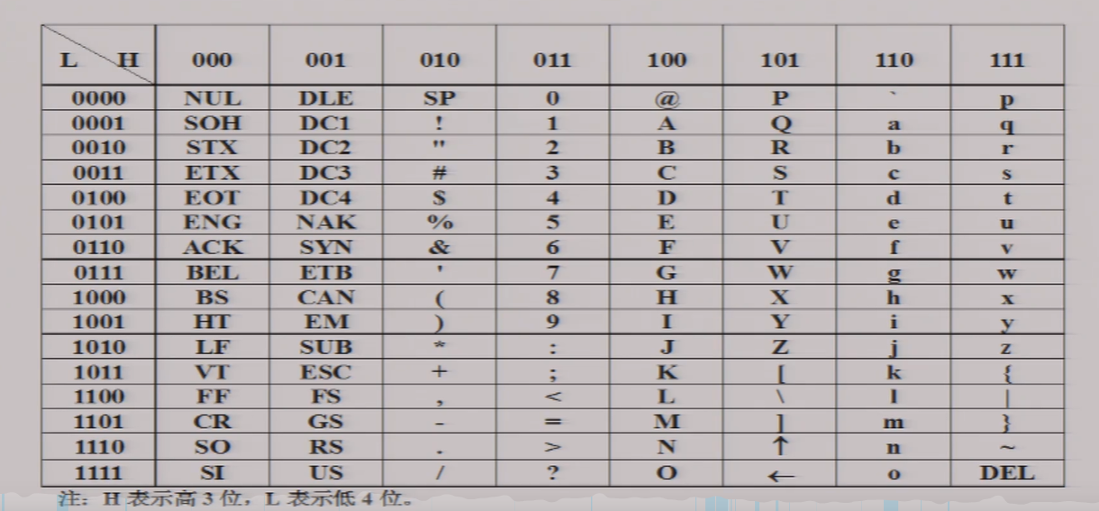

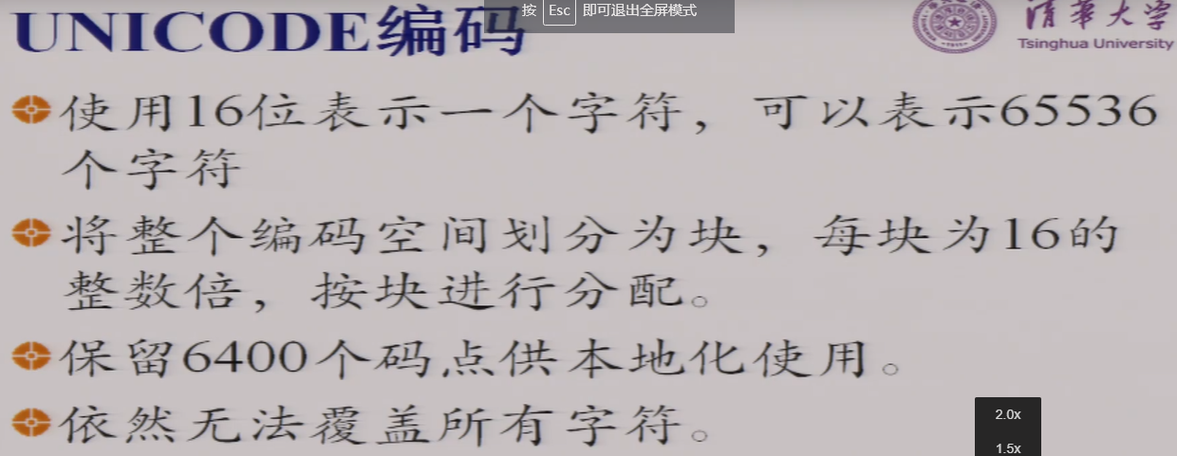

* https://timgsa.baidu.com/timg?image&quality=80&size=b9999_10000&sec=1604380099749&di=2ad53474e92e27a3ea6260cd150c65c3&imgtype=0&src=http%3A%2F%2Fpic.baiqi008.com%2Fuploads%2Fwearurusax.jpeg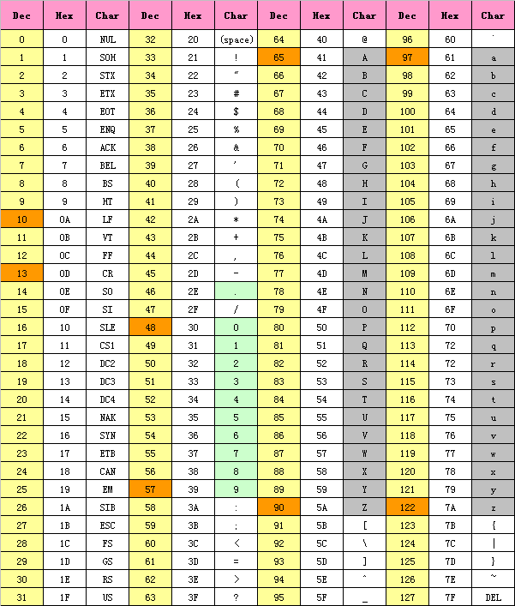

Ascii码

GB2312 GBK （含生僻字） 3个字节

常见的 2^8 2^16 2^32 2^10

UTF-8

